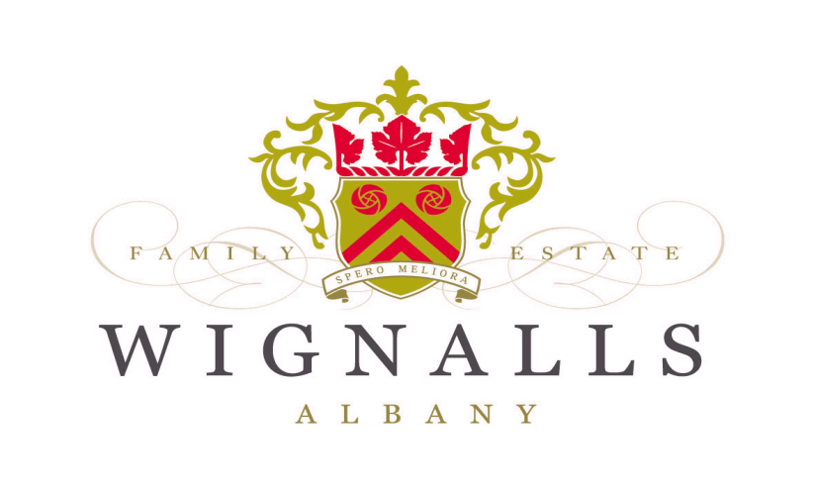
Wignalls “Albany Dew” Rose` 2022

Fruit Source:
100% Wignalls Vineyard,

Fruit Varieties:
20% Cabernet Sauvignon
40% Cabernet Franc
40% Pinot Noir

Our “Albany Dew” named after a local wildflower, is designed to be enjoyed for good times with good friends. A touch of sweetness as described as “off dry”, is apparent (3 grams per litre) on the palate along with a strong perfumed nose of Strawberries and Violets.

Particular attention has been paid to the slight residue sweetness to make sure that it does not “override” the subtle fruity characters, thus leaving the finish clean and refreshing, ready for the next glass around the BBQ.

Cellaring is not required and this wine should be enjoyed within one vintage year and served cold.

